

NOISE POLLUTION MONITORING SYSTEM

PROJECT-REPORT

DEPARTMENT OF BIO - MEDICAL ENGINEERING

Submitted By:

J.AROKKIYADASS

R.ARULMURUGAN

M.DHINESHPRABU

S.GIRINATH

S.CHANDRU

INTRODUCTION:

The main objective IOT based noise pollution monitoring system. The purpose of controlling and monitoring different activities and parameter which is focus of innovation in today’s technology for reading human needs, and demands of ease of use technology. To monitor and asses the condition in case of exceeding the prescribed level of parameters an efficient environmental monitoring system is required the different parameter data can be accessed by uses through an app which we provide namely “BLYNK” which is user Node MCU is used to make the model compact and easy to built with complexity which increases the easy handling services.

The advantages of node MCU over ardiuno is discussed in paper later. So a solution for monitoring the noise and CO levels in air in a particular area exceeding the normal levels etc.., in the environment using wireless embedded computing system is proposed in this paper.

PROPESED MODEL:

In our propesd model we are using gas sensor (MQ-135, MQ-7) noise sensor, temperature and humidity sensor to interface it with node MCU by using relay as it provide to read more than one analog values which overcome the limitation of node MQ having only one analog pin. In this model the sensor will sense the noise. Where the whole data is analyzed by the sensor and is send then to be accessed by the user through the app which is installed is there respective smart phone or computer

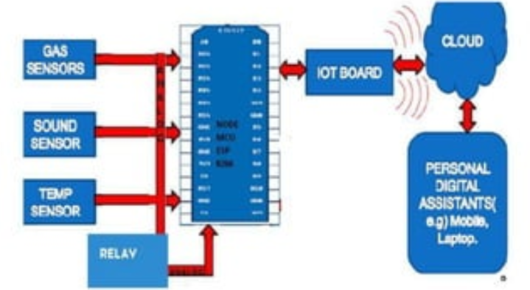

WORKING:

The gas sensor sense the value then sends the analog value through relay to the node MCU where the microcontroller reads the value and sends it to the cloud server. The gas sensor works on the principle of resistance where two resistance are present in the sensor one which senses the heat (Rh) and one is sensor (Rs) when the gas enters into the sensor the resistance values Rh and Rs changes. The sensor gives the ratio of Rs/Rh which varies with different gases follows different properties hence the resistance value is given through a formula where Rs,Rh and Vout value of sensor is used then the Ro is given in ppm it’s unit.

WORKING EXPLANATION:

COMPONENTS:

MQ-7 SENSOR

This semiconductor gas sensor detect the presence of carbon monoxide

Simple, compact, easy to handle

Long life and less cost

SOUND SENSOR MODULE

A mic is used to capture the sound signal sensitive material which converts sound energy into electrical energy

Easy to use sound sensor module

Provide analog or digital signal

HUMIDITY SENSOR

This DH11 has future a calibrated digital signal output.

Complex

High Reliability

Long term stability

MQ 135 GAS SENSOR

The MQ series of gas sensor utilized a small heater inside with an electro chemical.

High sensitivity

High temperature

NODE MCU

It is open source IOT platform

TYPE : Single based microcontroller

OS : XTOS

CPU : 128KB

MEMORY : 4MB

PROBLEMES:

Stress related illness, high blood pressure, speech interference, hearing loss , sleep disturbtion, loss productivity, air and sound pollution is growing issue this days.

APPLICATIONS:

* Road side pollution monitoring
* Industrial parameter monitoring
* Indoor air quality monitoring
* Design server using IOT and upload data on that server with data and time